***Lyddie***

***Chapter 7 – South to Freedom***

* Lyddie wanted to start off on her [journey](http://bookbuilder.cast.org/view_glossary.php?book=110039&word=96282#curr)  right away, but first Triphena made her take a new pair of boots and five [silver dollars](http://bookbuilder.cast.org/view_glossary.php?book=110039&word=96283#curr) to help her.  Lyddie said thank you to Triphena and [offered](http://bookbuilder.cast.org/view_glossary.php?book=110039&word=96284#curr)  to pay her back, but Triphena said that helping Lyddie get to the factory safely was [payment enough.](http://bookbuilder.cast.org/view_glossary.php?book=110039&word=96285#curr)
* Lyddie left.  She walked until it began to [pour](http://bookbuilder.cast.org/view_glossary.php?book=110039&word=96286#curr)  rain outside and she was [soaked](http://bookbuilder.cast.org/view_glossary.php?book=110039&word=96287#curr) .  Lyddie knew she needed to stop at the [local](http://bookbuilder.cast.org/view_glossary.php?book=110039&word=96288#curr)  village for the night.  A woman at the local tavern saw Lyddie when she arrived at the village.  The woman told her that a carriage would be coming towards the end of the week which could take her to [Lowell](http://bookbuilder.cast.org/view_glossary.php?book=110039&word=96289#curr) .  The woman told Lyddie that to pay for her [coach fare](http://bookbuilder.cast.org/view_glossary.php?book=110039&word=96290#curr) should could work at her tavern until the coach came.
* 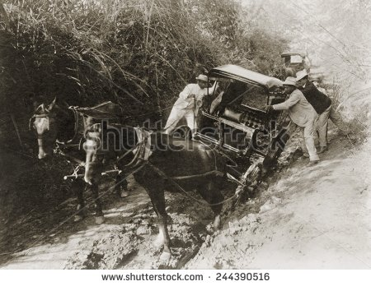
* On Thursday the carriage came and Lyddie got on.  It was crowded with six people [squeezed](http://bookbuilder.cast.org/view_glossary.php?book=110039&word=96291#curr)  into it and it was very [uncomfortable](http://bookbuilder.cast.org/view_glossary.php?book=110039&word=96292#curr) .
* As they got closer to Lowell, the carriage got stuck in the mud.  Lyddie watched as the [well dressed](http://bookbuilder.cast.org/view_glossary.php?book=110039&word=96293" \l "curr)  men tried to get the carriage out of the mud.  Lyddie knew she wasn't supposed to but got out of the carriage and went into the mud to help push the carriage out.  And with Lyddie's help, the carriage came out of the mud.  Everyone in the carriage was [shocked](http://bookbuilder.cast.org/view_glossary.php?book=110039&word=96294#curr) .  A woman had helped all of the men fix the carriage and had done so in the mud!
* 
* After the carriage was out of the mud they could continue on towards Lowell.
* After not too long they arrived.  When Lyddie got out of the carriage the driver offered to take her to his sister's [boardinghouse](http://bookbuilder.cast.org/view_glossary.php?book=110039&word=85121#curr) called [Number Five Concord Manufacturing Corporation](http://bookbuilder.cast.org/view_glossary.php?book=110039&word=96295#curr) as payment for her help getting the carriage out of the mud.

* 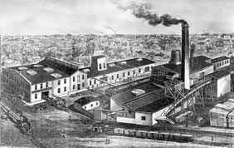
* As the driver's carriage pulled up to the boardinghouse Lyddie was shocked by the factory and the houses.  It was HUGE and NOISY and had [chimney](http://bookbuilder.cast.org/view_glossary.php?book=110039&word=85122#curr) 's that were [belching](http://bookbuilder.cast.org/view_glossary.php?book=110039&word=85123#curr)  smoke into the sky.  Lyddie didn't know what to think.
* y working at the mills in Lowell, MA.

In a few of the chapters preceding chapter 7, [Lyddie](https://www.enotes.com/topics/lyddie?en_action=hh_answer_body_click&en_label=%2Fhomework-help%2Fwhat-chapter-7-lyddie-1113749%23answer-790051&en_category=internal_campaign) has been hard at work at Cutler's tavern.  She is worked hard there, but she did have a small interaction with a woman that works in the factories and makes a good wage.  At the end of chapter 6, Lyddie is fired from Cutler's tavern, so she decides that she will head to Lowell, Massachusetts in order to find work in the factories there.  Chapter 7 is about her journey there on the carriage.  Lyddie is the only hardworking, streetwise person on the entire carriage.  This becomes evident when the carriage gets stuck.  The men that are riding on the carriage are completely useless and have no idea how to go about getting the carriage unstuck.  Lyddie eventually gets frustrated with their ineffectual efforts, and she steps in to do the job herself.  She successfully gets the carriage unstuck.  The driver is quite impressed with Lyddie's strength, knowledge, and tenacity, and he tells Lyddie where to find lodging with his sister, Mrs. Bedlow. Mrs. Bedlow turns out to be a wonderful resource and helps Lyddie obtain clothing and a place to stay.  Mrs. Bedlow turns out to be a good friend for Lyddie as well.